POSITION PAPER | BRUSSELS | 27 FEBRUARY 2023

**Geoscience, a Tool for Civil Protection Against Earthquakes**

*Intelligere, tueri noscendas* – To understand, to identify and to protect

The recent seismic events on Monday, 6th February 2023, in Eastern Turkey and Northern Syria claimed the lives of at least 50,000 people[1][2] and injured more than 70,000 persons[3]. The earthquake, with a magnitude (M) of 7.8 was followed by a strong aftershock with 7.5 in magnitude and at least 200 aftershocks (M>4.0). In addition to the fatalities and injuries, the extensive structural damages – 84,000 buildings have either been severely damaged, need urgent demolition, or collapsed[4] - have left more than one million people homeless along with an economic cost expected to run into billions of dollars[5].

According to the World Health Organization[6], about 23 million people, including 1.4 million children, are likely to be affected by this disaster. This figure is expected to rise dramatically due to the harsh winter conditions in the regions with hard access and political instability.

Turkey sits on the Anatolian plate between two major faults: the North Anatolian Fault and the East Anatolian Fault. The tectonic plate that carries Arabia, including Syria, is moving northwards and colliding with the southern rim of Eurasia, which is squeezing Turkey out towards the west (see figure above[7]). Consequently, this region has suffered from catastrophic earthquakes in the past. Turkey has been hit by 21 earthquakes of magnitude 7 or higher since 1900[8]. To geologists such events are not a surprise since plate boundary Fault Zones are far from “quiet” and Istanbul, the sixth-largest city in the world, lies just north of the North Anatolian Fault line which divides the Eurasian and Anatolian plates. **We simply need to look at historical seismic events and the biggest challenge is the difference in geological and human perception of time** (see the figure below[9]), where the first measure the time in million years, while the second measure the time in years or even days.

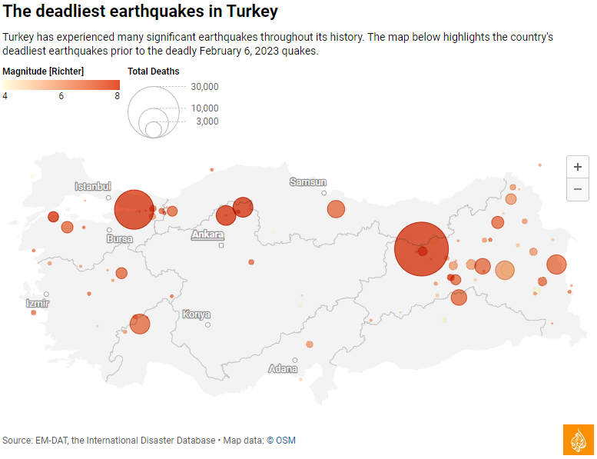

The financial cost of the recent earthquake in terms of direct and indirect loss is still unknown but is expected to be significant with losses estimated in billions of Euros. These figures are an indication of the funds that will be required every time similar events occur. As a result, resources of insurers and governments are exposed to higher stress and remove resources from society. Building stronger infrastructure and houses, while expensive, is only a part of the solution.

Current policy concentrates on reaction to disasters, rather than taking preventive and mitigation measures. Whilst earthquakes cannot be prevented and prediction is limited, their impact can be reduced through proper zoning and implementation of building codes based on site-specific risk analysis. Uncontrolled construction in hazard-prone areas and a focus on disaster reaction will only lead to a continuous increase in expenditure. Although focused on the US, a study by the National Institute of Building Sciences (NIBS) performed in 2019[10], showed that for every USD invested in following the building codes, 12 USD are saved. This ratio could also be translated to Euros.

**Therefore, the European Federation of Geologists recommends policy-makers to:**

1. **Integrate geological knowledge into future European Directives and national legislation.**
2. **Educate society to improve the understanding of and response to natural hazards.**
3. **Promote open access to scientific data and data products relevant to natural hazards.**
4. **Implement European coordination projects towards decreasing the seismic vulnerability of our cities.**
5. **Implement the concept of seismic microzonation studies to address site specific risk.**

The European Federation of Geologists (EFG), the professional body that represents 28 national geological association members, is drawing the attention of policy makers at international, European, national, regional, and local level to the paramount importance of geoscience in civil protection against natural hazards and especially in earthquakes.

The **EFG Panel of Experts on Natural Hazards** has been established in March 2003, in relation to European Commission initiatives on Civil Protection, DG Environment, and has since then provided many contributions to the European Commission. The whole group and its sub-group on earthquake related hazards have a collective 30 years of experience of forecasting and mitigating earthquake risk and designing robust solutions across the Mediterranean region. The Natural Hazards PoE in association with the Turkish, Italian and Greek Experts is available to provide information and to make recommendations from a geological perspective.

**About EFG:** The European Federation of Geologists is a non-governmental organisation that was established in 1980 and includes today 28 national association members. EFG is a professional organisation whose main aims are to contribute to a safer and more sustainable use of the natural environment, to protect and inform the public and to promote a more responsible exploitation of natural resources. EFG’s members are National Associations whose principal objectives are based on similar aims. The guidelines to achieve these aims are the promotion of excellence in the application of geology and the creation of public awareness of the importance of geoscience for the wellbeing of society.

For more information, please feel free to contact EFG Executive Director Mr. Glen Burridge ([glen.burridge@eurogeologists.eu](mailto:glen.burridge@eurogeologists.eu)) or Prof. Dr. Marko Komac, coordinator of the Panel of Experts on Natural Hazards ([coordinator.naturalhazards@eurogeologists.eu](mailto:coordinator.naturalhazards@eurogeologists.eu)).

1. <https://www.reuters.com/world/middle-east/earthquake-death-toll-surpasses-50000-turkey-syria-2023-02-24/>
2. <https://www.aljazeera.com/news/2023/2/19/earthquake-rescue-operations-ended-in-most-turkey-provinces-afad>
3. <https://www.redcross.org.uk/stories/disasters-and-emergencies/world/turkey-syria-earthquake>
4. <https://www.aljazeera.com/news/2023/2/18/earthquake-death-toll-surpasses-46000-in-syria-turkey?traffic_source=KeepReading>
5. <https://www.aljazeera.com/news/2023/2/19/earthquake-rescue-operations-ended-in-most-turkey-provinces-afad>
6. <https://www.reuters.com/world/middle-east/who-sayssyria-already-crisis-needs-massive-humanitarian-aid-afterquake-2023-02-07/>
7. <https://www.theguardian.com/world/2023/feb/06/turkey-syria-earthquakes-visual-guide>
8. <https://www.theguardian.com/world/2023/feb/06/turkey-syria-earthquakes-visual-guide>
9. <https://www.aljazeera.com/news/2023/2/13/hold-analysis-is-istanbul-ready-for-a-strong-earthquake>
10. <https://www.nibs.org/files/pdfs/NIBS_MMC_MitigationSaves_2019.pdf>